Journal: Ecology
Article Title: Interpreting field measurements of juvenile growth and survival rates with population growth isoclines
Authors: Nathan T. Barrus, Mark I. Cook & Nathan J. Dorn.

Appendix S2: Survival and Growth
Study map
We took empirical measuments of daily survival and growth in the wet and dry season within the experimental wetlands of the Loxahatchee Impoundment Landscape Assessment (LILA) and sites within everglades as shown in Figure S1.
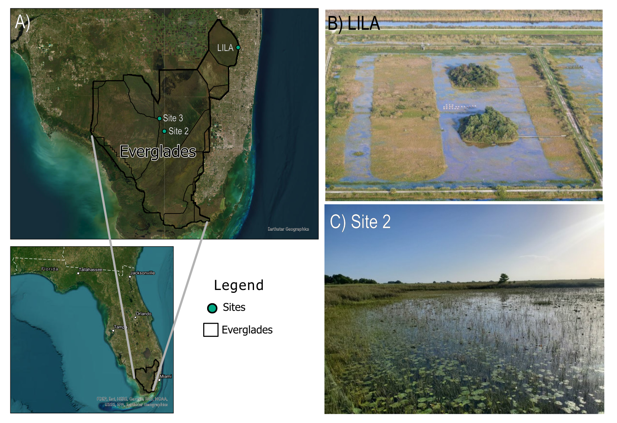
Figure S1 A) Map and images of B) LILA impoundment #2 and C) Site 2 in Water Conservation Area 3A. Photo credits to B) Mark I. Cook and C) Nathan T. Barrus.

Tethering
We conducted tethering experiments to measure survival of snails < 10 mm SL in LILA and in WCA3A each season to relate to the zero-population growth isocline. The experiments in the LILA wetlands also allowed us to test for size-dependent survival more broadly. We tested size- and season-dependent survival in two wetlands in LILA by tethering lab-reared juvenile snails from hatchling to adult sizes (3-30 mm SL) each season and measuring 24 h survival. In WCA3A, we only tethered juvenile snails (3-10 mm SL). Each tethering experiment was conducted by attaching snails to PVC poles with monofilament line on transects within the sloughs (Figure 3). The transects attempted to capture potential spatial variation in survival and were arranged “near” or “far” from the ridge edge (~5m and 15-20m, respectively). Across transects, tethered snails were placed apart to increase spatial representation and independence (Figure 3). We included 5-10 replicates of 3-mm size increments (i.e., 3-6mm, 6-9mm, 9-12mm,12-15mm, 15-18mm, 18-21mm, and >21mm SL) on each transect in LILA and 10-15 replicates of each 3-mm size increment (i.e., 3-6mm, 6-9 mm, >9 mm) in WCA3A. Snails were tethered by gluing 20 cm of either 2.4 lb (FAS ≤6mm SL) or 4 lb (FAS ≤6mm SL) monofilament line to the shell apex. Poles were placed ≥2 m apart and additional methodological details and the spatial considerations can be found in the supplement.
Tethering experiments were run for two-three days and snail status was checked daily. We checked snail status by prodding the operculum to incite movement, and we scored the status by five categories: (1) “missing” if the snail was removed from the tether, (2) “crushed/peeled” if the tether had shell fragments remaining on the tether, (3) “empty” if the soma from the shell had been removed, (4) “dead” if snails did not respond when prodded and (5) “alive” if snails responded when prodded. Using the snail status measures, snails that were “alive” were counted as survivals, while snails that were deemed “missing”, “crushed”, “dead”, or “empty” were counted as mortalities. Surviving snails were placed back onto PVC poles and mortalities were replaced with tethered snails of the same size. To generalize measured survival to a larger area than the initial locations, tethers were moved two meters in a randomly chosen cardinal direction to increase independence between nights. The fate of each snail-day combination was considered an independent measure of daily survival. We ran the tethering experiments to achieve ~ 30 observations of mortality per size class. To ensure that snails could not escape tethers, tethered snails within each size class were caged in LILA for 72 hours to exclude predators. No snails escaped or died on tethers during 72 hours in the cages.
We analyzed the tethering dataset from LILA that tethered the full-size range of snails using logistic regression to test for size and season dependence of daily survival. We modeled survival using length (SL mm), transect (“near” or “far”), wetland (“M2” or “M4”), and season (“wet” or “dry”) as covariates. We created a list of logistic models that included all possible combinations of these covariates and their two-way interactions (Table S2). Higher order interactions were excluded. The resulting models were compared using AIC scores, the structure of models with ΔAIC < 4 were examined, and the most supported model (lowest AIC) was selected for interpretation and evaluation. Logistic regression was fitted using the “glm” function in R v4.0.3 (R Core Team, 2023).
Overall, we observed a total of 759 independent observations of survival across two wetlands and two tethering seasons in LILA. After 24 hours, 654 snails survived, 43 snails were missing, 31 snails were empty, 19 snails died on tethers, and 12 snails were crushed/peeled. Daily survival across all sizes was 0.862. The daily cumulative survival for smaller juvenile snail size classes (< 10 mm) was slightly lower (0.821) than survival across all sizes (0.862). Daily survival in predator exclosure cages was almost 100% (cumulative mean = 0.997, se = 0.001, n = 49 days) and did not differ between seasons (overlapping 95% confidence intervals; Figure S4). One of the cages was eliminated from the analysis because it was colonized by a single giant water bug and only empty shells were left by the end of the experiment.
In WCA3A, we observed a total of 276 independent observations of survival across the sites and seasons. After 24 hours, 240 snails survived, 21 snails were left empty, 3 snails had been crushed/peeled, 3 snails died on tethers, and 2 were missing. Only small snails were tethered, and daily survival for these small sizes was higher (0.892) than those in LILA (0.821).
We found the size-dependency of FAS survival changed with seasons. The top four models (cumulative weight = 0.95) for predicting daily survival probability included SL, Season, and the interaction between Length and Season (Table S1). The top model did not include any additional variables, but the next three best models (ΔAIC ≤ 2.74) included combinations of spatial factors. The parameter values for the spatial factors appeared to provide little additional predictive capacity (parameter p-values ≥ 0.276) to survival, so we restricted interpretation to the size and season parameters (Figure S1). During the dry season, FAS daily survival probability increased with size (z = 2.667: p = 0.008; Figure S1), but in the wet season, daily survival probability was size independent (z = -0.902: p = 0.367; Figure S1). Small juvenile snails (< 10 mm SL) survived better in the wet season than the dry season (Figure S1).

Table S1: AIC model selection table for logistic regression predicting daily survival probability of FAS (Pomacea paludosa) in two LILA wetlands. Daily survival was measured with snails (Length: 3-30 mm SL) on tethers during the dry and wet seasons on transects located closer and further from habitat edges in sloughs.
Model description | AIC | ΔAIC | w
Length + Season + Length*Season | 519.870 | 0.000 | 0.398
Length + Season + Wetland + Length*Season | 520.755 | 0.885 | 0.256
Length + Season + Transect + Length*Season | 521.482 | 1.612 | 0.178
Length + Season + Wetland + Transect + Length*Season | 522.387 | 2.517 | 0.113
Length + Season | 527.249 | 7.379 | 0.010
Season + Wetland | 527.993 | 8.123 | 0.007
Transect + Season + Length | 528.705 | 8.835 | 0.005
Length + Wetland + Season + Length*Wetland | 528.824 | 8.954 | 0.005
Transect + Wetland + Season + Length | 529.119 | 9.248 | 0.004
Season + Wetland + Length + Season*Wetland | 529.546 | 9.676 | 0.003
Season | 529.576 | 9.706 | 0.003
Wetland | 529.771 | 9.900 | 0.003
Transect + Length + Transect*Length | 529.844 | 9.973 | 0.003
Length | 529.982 | 10.112 | 0.003
Transect + Season | 530.487 | 10.617 | 0.002
Transect + Wetland + Season | 530.704 | 10.834 | 0.002
Length + Wetland | 531.284 | 11.413 | 0.001
Season + Wetland + Season*Wetland | 531.438 | 11.567 | 0.001
Transect + Length | 531.829 | 11.959 | 0.001
Transect + Season + Transect*Season | 531.998 | 12.128 | 0.001
Length + Wetland + Length*Wetland | 532.028 | 12.158 | 0.001
Transect + Wetland + Length | 533.135 | 13.265 | 0.001
Length + Wetland + Season | 534.472 | 14.601 | 0.000
Transect | 535.316 | 15.446 | 0.000
Transect + Wetland | 535.997 | 16.127 | 0.000
Transect + Wetland + Transect*Wetland | 537.412 | 17.542 | 0.000

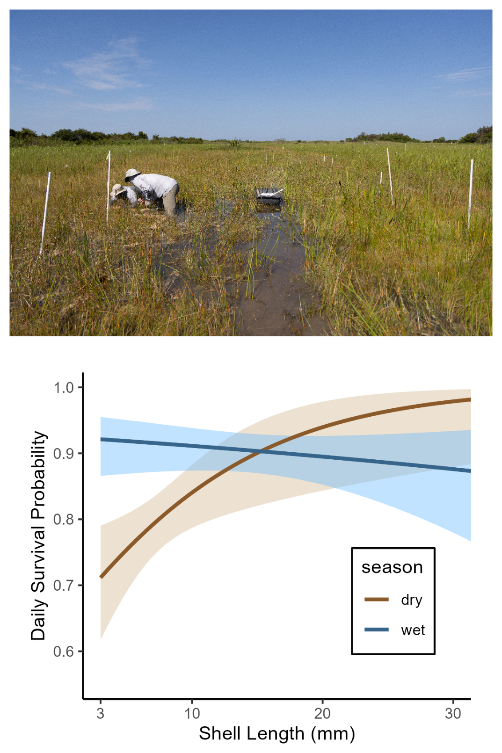
Figure S2: Field picture showing the transects of tethers in LILA wetlands used to estimate daily survival (photo credit: Brandon Güell). Daily survival probabilities estimated from logistic regression from tethering data. Shaded areas indicate standard error.

Predator abundance
Predator abundance was measured using the protocol similar to Dorn & Cook, (2015) (Sommer, 2021a). In both seasons, 1-m² throw traps were deployed at 14 randomly selected locations in the slough habitats. Each season sampling occurred when slough habitats were flooded but ridge habitats were shallow (< 10 cm) so for each season large predatory fishes were equally concentrated in the sloughs. Throw traps were cleared under the protocol described by Dorn et al., (2005). Captured animals were euthanized in MS-222 (Tricaine-S, Western Chemical Inc.), fixed (after 30-120 min) in 10% buffered formalin, then cleaned and stored in a 70% ethanol solution. In the lab using calipers, invertebrate predators (i.e., crayfish and giant water bugs) were selected and measured to carapace length and total length, respectively. Juvenile crayfish with carapace lengths < 14 mm were excluded from analyses because they are not predators of juvenile apple snails (Davidson & Dorn, 2017). Trap nets (i.e., fyke and hoop nets) were placed in the deep sloughs of wetlands for three consecutive nights each season. Trapping in each wetland consisted of four fyke nets (0.7 x 1 m opening, 3 mm mesh, 2 throats) and five mini hoop nets (0.6 m diam. opening, 1 cm mesh, 2 throats; ) and captures across all gear types were combined to calculate a nightly catch index. Molluscivorous fishes larger than 5 cm were identified, measured (standard length) and released while Greater Sirens were counted and released.
Invertebrate Predator maximum size selection experiment
The purpose of this experiment was to test for the maximum size of apple snail (P. paludosa) that a crayfish (Procambarus fallax) or giant water bug (Belostoma lutarium) would eat. Predators were captured in the Loxahatchee Impoundment Landscape Assessment (LILA) located in Boynton Beach FL using wire minnow traps, then we brought the predators to the green house at the Florida Atlantic University’s campus in Davie FL, where they were housed in 1.1 m2 round mesocosms (for crayfish) or 10-gallon aquaria (for giant water bugs). Before placing predators into experimental containers, we measured crayfish and giant water bugs to Carapace Length (CL) and Total Length TL), respectively. Three crayfish, and 5 giant water bugs were then placed into 8 15L-Sterilite containers filled 2/3 full of pond water. In each container, we placed 3 strands of sawgrass (Cladium jamaicense; collected from plants already growing at the green house) for giant water bug perching sites, one 3–4-inch piece of 1 inch diameter PVC pipe was added as hiding place for crayfish, and an air bubbler was added in experimental containers to keep the containers well saturated with dissolved oxygen. After starving the predators for 24 hours, we placed a large snail (i.e.,snails larger than the predator could eat; 21-25 mm shell length-SL) into each experimental container for another 24 hours, then we progressively offered a smaller snail (~4 mm SL increments) to each predator for another 24 hours until the predator ate a snail. We measured each snails SL prior to offering the snail to a predator, so we knew the exact SL of each snail that the predator ate. The results of this experiment are summarized in Table S2
Table S2: Table illustrating the results of the predator selection experiment. Each column gives the predator and size while each row shows the SL of snail presented to the predator. The black dots in the cells indicates that a snail in the given size category was presented but not eaten. The cells that contain a number indicate the actual size of the snail eaten by the predator.
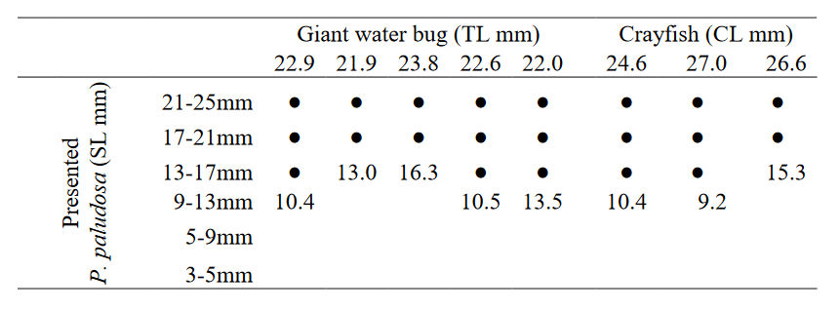
Diet Composition of Mayan Cichlids and Greater Sirens
On the final day of trap netting in the dry and wet season sampling events of 2021, Mayan Cichlids, known to eat freshwater gastropods, were euthanized in MS-222 (Tricaine-S, Western Chemical Inc.), placed on ice, then frozen in the lab for later use in gut-content analysis. Mayan Cichlids and Greater Siren diet samples were analyzed in the lab (gut and fecal samples respectively). The alimentary canal of each Mayan Cichlids was removed and rinsed with 70% ethanol to remove any contents. Greater Siren fecal samples were obtained from Hunter Howell from the University of Miami. The contents were searched and, when possible, identified to lowest possible taxonomic group. The primary goal of the gut content analysis was to find relative sizes of gastropod prey. Whole gastropod in diet samples were measured for Shell Length (SL), but when crushed gastropods were found in diet samples, the apex of the shell was located and compared to apexes of intact shells with known shell lengths.
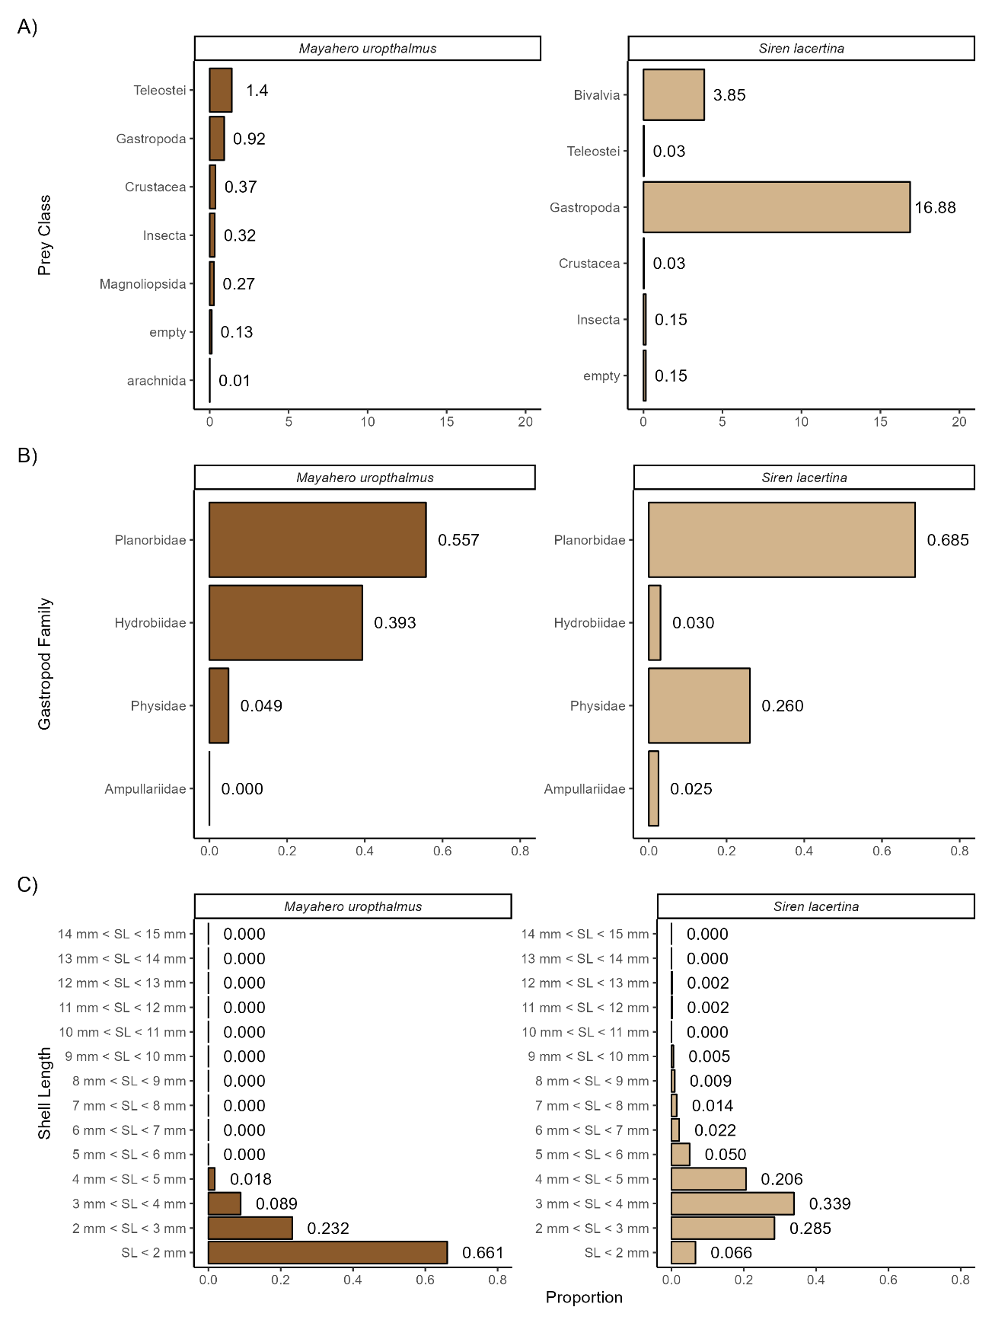
Figure S3: Diet composition of Mayan Cichlids and Greater Sirens. A) per-capita consumption of different orders of prey types. B) composition of gastropod families found within the gastropod portion of the diets. C) size distribution of gastropods found within the gastropod portion of diets.

Relative composition of predation from tethering remains and abundances
For the full tethering experiment in LILA, we determine the relative strength of predation by each juvenile predator between seasons by exploring three different aspects of predation. 1) We looked at the differences in the counts of the three artefacts related to predators (crushed/peeled, empty, missing) across seasons. Crayfish use their mandibles to crush or peel the snail shell to remove the soma (Davidson & Dorn, 2018). In contrast, giant water bugs pierce the snail operculum then suck out and remove snail soma without damaging the shell (Kesler & Munns, 1989). We confirmed the artefactual differences by placing tethered snails in aquarium in the presence of predators. 2) We looked at seasonal changes in abundance of the three predators (i.e., giant water bugs, crayfish, and greater sirens) that were most likely responsible for the artefacts. Predator abundance data was taken from small and large animals sampling in the dry and wet season of 2021 using throw traps and trap nets (i.e., fyke and hoop nets) under a protocol similar to (Dorn & Cook, 2015) (further explained in next subsection and Sommer 2021). 3) We divided the counts of the artefacts by the seasonal abundance of the different predators to estimate per-capita predation rates.
We found tethers retained crushed/peeled shells when consumed by crayfish and empty shells when consumed by giant water bugs Table S2. We interpreted lost snails as vertebrate predation. We examined the stomach and fecal contents of greater sirens and mayan cichlids collected from trap-net monitoring to determine which vertebrate predators was likely to have removed snails from the tethers (Table S2; Figure S2). The size range of snails found in mayan cichlids (snails < 3 mm SL) was typically smaller than hatchling FAS (3 mm SL) whereas the size range of snails found in the diets of greater sirens overlapped the sizes of juvenile FAS (3-10 mm SL; Figure S2). And juvenile FAS were found in the diets of greater sirens but not mayan cichlids (Figure S2). No redear sunfish were caught in the trap nets during this study. From the laboratory, dietary, and capture observations, we interpreted a “crushed/peeled” shell as mortality caused by crayfish (Figure S3), “empty” shell as mortality caused by giant water bugs (Figure S3), a “missing” shell as caused by greater sirens (Figure S3), and “dead” as a caused by something abiotic.
The mortality artefacts of juvenile snails from LILA wetlands (i.e., shell conditions) indicated that there were more than 60% more juvenile predation events in the dry season than the wet season (Figure S3). Giant water bugs, crayfish, and greater sirens were 45, 66, and 77 percent less abundant in the wet season sampling than the dry season, respectively (Figure S3). Except for giant water bugs, per-capita predation (artefacts/abundance) increased in the warmer wet season. Although predator abundance and per-capita predation rates were not explored in WCA3A, the seasonal change in artefact counts in WCA3A were consistent with those found in LILA, except vertebrate predation (missing artefacts) was essentially absent.

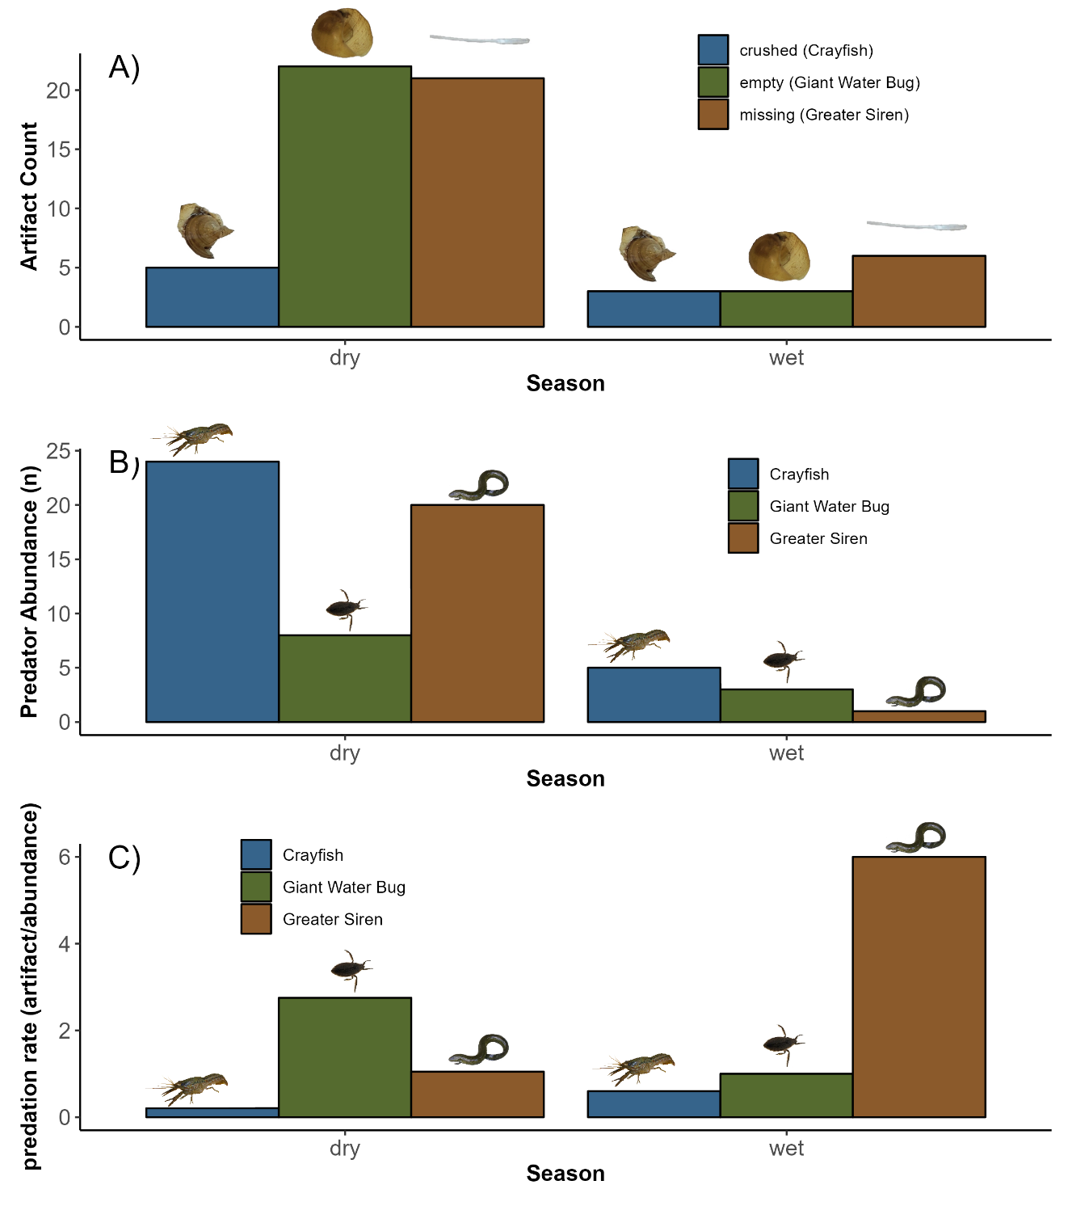
Figure S4: A) Counts of artefacts of biotic factors causing mortality of snails (< 10 mm SL) in the two seasons in the LILA wetlands, and B) seasonal abundance of predators of juvenile snails from throw-trap samples (crayfish and giant water bug), and from standard sets of trap nets (greater siren). Sampling effort was equal in each season. C) Per-capita predation rate from the different predators in the two seasons. Vector images were created from images taken by Nathan T. Barrus.
Daily survival in predator exclosure cages
Snail survival was checked at the end of the in situ cage experiment and dead snails (i.e., their shells) were measured for shell length (SL). To obtain the duration that the snail survived I used the modelled growth equation to find the SGR_{L} that would be expected for that snail’s initial size. Using the expected SGR_{L} for the snail’s initial size, the SGR equation can be rearranged to back-calculate the time that the snail lived in the cage:
$$t=\frac{(\log\left(L_{f}\right)-\log\left(L_{i}\right))}{{SGR}_{L}}$$
The daily average survival was found by averaging the proportion of snails alive on the given day. If a snail had died on a given day, it was removed from further proportions. One predatory B. lutarium colonized a cage in the dry season and all four snails were killed, this cage was excluded from this analysis.
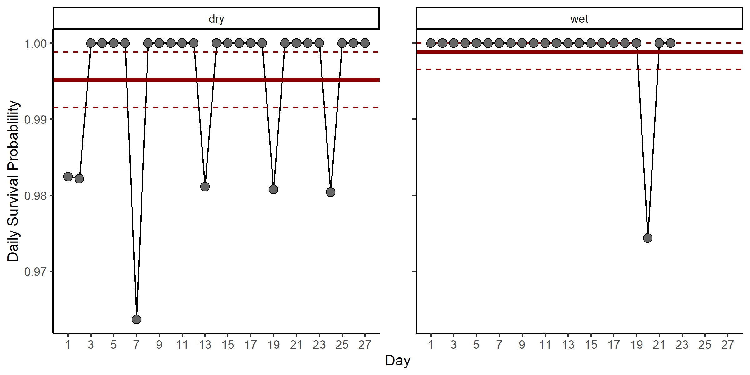
Figure S5: C) The daily survival probabilities obtained from the back calculated time of deaths of snails in the enclosure cages. The solid red line indicates the mean and dashed red lines indicate the 95% confidence intervals for daily survival probabilities across the duration of the experiment.

Calculating the growth parameter
The age-structured population model (Darby et al., 2015) used the following equation to model growth of FAS.
$${Size}_{{time}_{i}}= \frac{{Size}_{initial}e^{k_{growth}∙{time}_{i}}}{1+(\frac{{Size}_{initial}}{{Size}_{max}})(e^{k_{growth}∙{time}_{i}}-1)}$$
where time is the duration of growth, and Size_{initial} is the initial length of the snail, Size_{max} is the maximum length that an adult can reach (assumed to be 50 mm SL). Because we knew the Size_{intial}, size_{max} and time, we could then calculate k_{growth} for each snail by rearranging the equation.
$$k_{growth}= \frac{\ln\left({size}_{{time}_{i}}\left(1-\frac{{size}_{initial}}{{size}_{max}}\right)\right)-ln⁡({size}_{initial}\left(1-\frac{{size}_{{time}_{i}}}{{size}_{max}}\right))}{time}$$

References
Barrus, N. T., Drumheller, D., Cook, M. I., & Dorn, N. J. (2023). Life history responses of two co-occurring congeneric Apple Snails (Pomacea maculata and P. paludosa) to variation in water depth and metaphyton total phosphorus. Hydrobiologia, 850(4), 841–860. https://doi.org/10.1007/s10750-022-05128-9
Darby, P. C., DeAngelis, D. L., Romañach, S. S., Suir, K., & Bridevaux, J. (2015). Modeling apple snail population dynamics on the Everglades landscape. Landscape Ecology, 30(8), 1497–1510. https://doi.org/10.1007/s10980-015-0205-5
Davidson, A. T., & Dorn, N. J. (2017). Life history traits determine the differential vulnerability of native and invasive apple snails (Pomacea spp.) to a shared juvenile-stage predator. Aquatic Ecology, 51(3), 331–341. https://doi.org/10.1007/s10452-017-9620-9
Davidson, A. T., & Dorn, N. J. (2018). System productivity alters predator sorting of a size-structured mixed prey community. Oecologia, 186(4), 1101–1111. https://doi.org/10.1007/s00442-018-4099-1
Dorn, N. J., & Cook, M. I. (2015). Hydrological disturbance diminishes predator control in wetlands. Ecology, 96(11), 2984–2993. https://doi.org/10.1890/14-1505.1
Dorn, N. J., Urgelles, R., & Trexler, J. C. (2005). Evaluating active and passive sampling methods to quantify crayfish density in a freshwater wetland. Journal of the North American Benthological Society, 24(2), 346–356. https://doi.org/10.1899/04-037.1
Drumheller, D. K., Cook, M. I., & Dorn, N. J. (2022). The role of direct chemical inhibition in the displacement of a native herbivore by an invasive congener. Biological Invasions, 24(6), 1739–1753. https://doi.org/10.1007/s10530-022-02752-3
Gaiser, E. E., McCormick, P. V., Hagerthey, S. E., & Gottlieb, A. D. (2011). Landscape Patterns of Periphyton in the Florida Everglades. Critical Reviews in Environmental Science and Technology, 41(sup1), 92–120. https://doi.org/10.1080/10643389.2010.531192
Kesler, D. H., & Munns, W. R. (1989). Predation by Belostoma flumineum (Hemiptera): An Important Cause of Mortality in Freshwater Snails. Journal of the North American Benthological Society, 8(4), 342–350. https://doi.org/10.2307/1467497
R Core Team. (2023). R: A Language and Environment for Statistical Computing. [Computer software]. R Foundation for Statistical Computing. https://www.R-project.org/
Sommer, J. L. (2021a). Effects of Wet Season Hydro-patter on Crayfish (Procambarus fallax) population density and juvenile mortality risk (Issue May). Florida Atlantic University. Boca Raton, FL.
Sommer, J. L. (2021b). Effects of wet season hydro-pattern on crayfish (Procambarus fallax) population density and juvenile mortality risk [Masters of Science]. Florida Atlantic University.

